Account Application Form for Cygnet Yarns Ltd 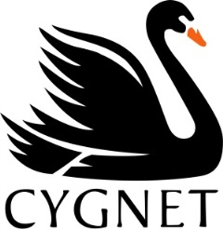

Company Name: ……………………………………………………………………………………………...

Company Contact Name: ……………………………………………………………………………………

Company Address: ……………………………………………………………………………………………

………………………………………………………………………………………………………………......

………………………………………………….……………………………………………………………….

Company Tel. No……………………………….

Email address:………………………………………………………………….

Delivery Address (if different from above) …………………………………………………………………….

…………………………………………………..……….........................................................................
Nature of Business

Bricks & Mortar Shop

Online

Online & Bricks & Mortar

Social Media

Ebay/ Amazon

Other ………………………………………….

How did you hear about us?

Friends & Family

Google

Recommendations

Social Media

Other………………………………………………

TICK here if you would like us to Sign you up to our Wholesale area on our website.
(upon approval you can access pricing, order online and register for our newsletter)

